FUEL REFRACTORIES AND FURNACES

LECTURE NOTES

Compiled at
Department of Mineral Engineering
Government College of Engineering, Keonjhar, Odisha

DISCLAIMER

THIS DOCUMENT DOES NOT CLAIM ANY ORIGINALITY AND CANNOT BE USED AS A SUBSTITUTE FOR PRESCRIBED TEXTBOOKS. THE INFORMATION PRESENTED HERE IS MERELY A COLLECTIONFROM DIFFERENT REFERENCE BOOKS AND INTERNET CONTENTS.THE OWNERSHIP OF THE INFORMATION LIES WITH THE RESPECTIVE AUTHORS OR INSTITUTIONS.

FUEL, REFRACTORIES& FURNACES(3-1-0)

Module-I (10 hours)
Definition of Fuel; Types of Fuel; Conventional and Non-conventional Fuel; Types of Energy Resources; Potential of Energy Resources and their exploitation
Module-II (08 hours)
Types of solid fuels. Origin and formation of coal. Classification of Coal.
Module-III (08 hours)
Types of furnaces and classification, Industrial application of furnaces, design and construction aspects of furnaces. Chimney design, process efficiency.
Module-IV (14 hours)
Refractories: refractory material and characterization, types of Refractories and their application in boilers and furnace construction. Properties and testing methods of Refractories. Manufacture of fire basic bricks, acidic and neutral Refractories, refractory mortars, cements and monoliths, special refractory and ceramics. Role of refectories in energy conservation in furnaces.
TEXT BOOK:
1. Elements of Fuels, Furnaces and Refractories by O.P. Gupta, Khanna Publ., 1997
2. Fuels and refractories by Book by J. D. Gilchrist

MODULE-I

Fuel:
Energy from the Sun is converted into chemical energy by photosynthesis. But, as we know,when we burn dried plants or wood, producing energy in the form of heat and light, we arereleasing the Sun’s energy originally stored in that plant or in that wood throughphotosynthesis. We know that, in most of the world today, wood is not the main source offuel. We generally use natural gas or oil in our homes, and we use mainly oil and coal to heatthe water to produce the steam to drive the turbines for our huge power generation systems.
The substances which give energy in the form of heat and light on theircombustion with air in a manner which could be utilised efficiently andeconomically are known as fuel.
These fuels - coal, oil, and natural gas - are often referred to as fossil fuels.
The various types of fuels (like liquid, solid and gaseous fuels) that are available depend onvarious factors such as costs, availability, storage, handling, pollution and landed boilers,furnaces and other combustion equipment.
The knowledge of the fuel properties helps in selecting the right fuel for the right purpose andfor the efficient use of the fuel. Laboratory tests are generally used for assessing the natureand quality of fuels.
Conventional and Non-conventional Source of Energy:
- Conventional Energy Sources:
Conventional sources of energy are also called non-renewable sources. These sources of energy are in limited quantity except hydro-electric power.
These are further classified as commercial energy and non-commercial energy:
- Commercial Energy Sources:
These are coal, petroleum and electricity. These are called commercial energy because they have a price and consumer has to pay the price to purchase them.
- Non-Commercial energy Sources:
These sources include fuel wood, straw and dried dung. These are commonly used in rural India. According to an estimate, the total availability of fuel wood in India was only 50 million tonnes a year. It is less than 50% of the total requirements.
Agricultural wastes like straw are used as fuel for cooking purposes. The straw can be used as valuable organic manure for increasing fertility of soil and in turn productivity.
- Non-Conventional Sources of Energy:
Besides conventional sources of energy there are non-conventional sources of energy. These are also called renewable sources of energy. Examples are Bio energy, solar energy, wind energy and tidal energy.
The various sources are given below:
- Solar Energy:
Energy produced through the sunlight is called solar energy. Under this programme, solar photovoltaic cells are exposed to sunlight and in the form of electricity is produced. Photovoltaic cells are those which convert sun light energy into electricity. Solar energy is used for cooking, heating water and distillation of water etc.
- Wind Energy:
This type of energy can be produced by harnessing wind power. It is used for operating water pumps for irrigation purposes.
- Tidal Energy:
Energy produced by exploiting the tidal waves of the sea is called tidal energy. Due to the absence of cost effective technology, this source has not yet been tapped.
- Bio Energy:
This type of energy is obtained from organic matter.
It is of two kinds:
- Biogas:
Biogas is obtained from cow dung gas plant by putting cow dung into the plant. Besides producing gas this plant converts cow dung into manure. It can be used for cooking, lighting and generation of electricity.
- Biomass:
It is also of a source of producing energy through plants and trees. The purpose of bio mass programme is to encourage afforestation for energy. So that fuel for the generation of energy based on gas technique and fodder for the cattle could be obtained.
- Energy from Urban Waste:
Urban waste poses a big problem for its disposal and it can be used for generation of power.

Electrical Energy
Electrical energy is not a fuel but is a substitute for fuel and replaces it (or displaces it) in many industrial applications.
Electricity can be generated from several sources of energy.
- By conversion of chemical energy in coal, oil, peat or other conventional fuels into heat by burning, into mechanical energy by steam-raising, and then to electrical energy by using a turbine and dynamo.
- By conversion of the potential energy in water in elevated reservoirs to kinetic energy in raceways and then to mechanical and electrical energy using turbines and dynamos.
- By similar conversion of the kinetic energy in wind.
- By conversion of nuclear energy via heat and steam.
- By the use of electrolytic cells and fuel cells in which chemical energy can be converted directly to electrical energy.
TYPE OF FUELS
The fuels can be commonly classified on the basis of physical state of theiroccurrence, source, process of production and renewable/non-renewable qualityas follows:
- Physical state of fuel, i.e., solid (coal, coke, charcoal, etc.), liquid(petrol, diesel, etc.) and gas (methane, hydrogen, etc.).
- Source of fuel, i.e., primary sources like coal, crude oil, and natural gaswhich occur in nature or secondary sources like coke, diesel, hydrogen, etc.which are prepared by some industrial processes.
- Process of production, i.e., purposefully manufactured fuel likemetallurgical coke or by-product fuel like blast furnace gas.
- Nature of fuel—Non-renewable (fossil) fuels like coal, crude oil, naturalgas or renewable fuels like hydrogen, biomass, etc.
PROPORTIES OF FUEL:
The various properties of liquid fuels are given below.
- Chemical composition: Carbon content, water content, ash content, sulphur, nitrogen, hydrogen content etc.
- Density
- Specific gravity
- Viscosity
- Flash point
- Pour point
- Specific heat
- Calorific value
The primary and secondary sources for solid, liquid and gaseous fuels,classified as renewable and non-renewable (fossil) fuel.
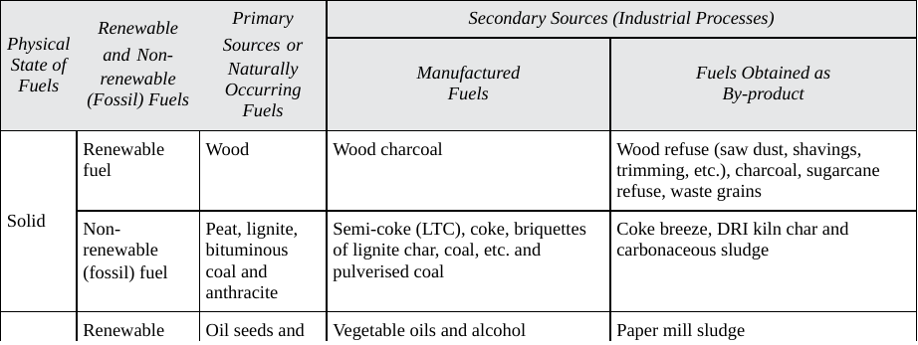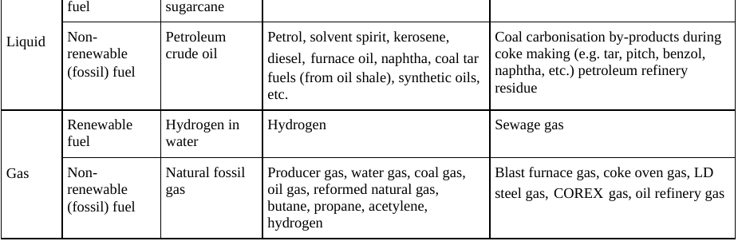

Liquid Fuels
Liquid fuels are mainly oils, tars and pitches and are derivedfrom the following sources:
- Petroleum
- Oil Shales
- Coal, by carbonization
- Coal, by hydrogénation
At present petroleum provides the majority of our liquid fuelrequirements. The reserves of oil shales are immense, however,and these will probably increase in importance in the future. Theliquid and tarry products of carbonization are used by industrynear coalfields and carbonizing centres and, as a result, the steelindustry employs these in fairly large quantities.
Hydrogénationof coal has been exploited mainly by the Germans using lignites.It competes economically with oil only with great difficulty butthe process has had strategic significance.
Refining of Petroleum:
Refining is the fractionation of the petroleum into its components and the first stage is a simple fractional distillation as follows:
- Natural gas—Boiling range below 30°C. This is usually removed under reduced pressure at the oilfield, initially to permit safe handling of the crude oil.
- Gasoline—Boiling range 30-200°C. This is "petrol" and may be further divided into aviation spirit (30-150°C), motor spirit(40-180°C), and vaporizing oil (110-200°C) for tractors, etc.
- Naphtha—Boiling range 120-200°C. There is usually a surplus at the top end of the gasoline range which is used for further processing. This is the fraction which is reformed to high octane gasoline and supplied to petrochemical plants as feedstock. It was also used for making into town's gas during the 1960s.
- Solvent spirit—Boiling range 120-250°C. This is white spirit or turpentine substitute and is used as a solvent, a cleansing agent and in paint manufacture.
- Kerosene—Boiling range 140-290°C. This fraction includes domestic paraffin oil (140-250°C) and heavier slow-burning fractions used as illuminants in railways (signal oil) and in lighthouses.
- Gas oil—Boiling range from 180°C and leaving a residue of carbon at 350°C. This is used as a carburetting oil in the gas industry and also in diesel engines.
- Fuel oils—Boiling above 200°C. Beyond this point vacuum distillation is necessary to avoid cracking of these heavy oils with the formation of lighter oil and carbon residue.
- Light fuel oil—Boiling above 200°C.
- Heavy fuel oil—Boiling above 250°C These are fractions of interest to furnace operators—for use in ships, land boilers, metallurgical furnaces, etc.
- The residue from these stages is becoming very thick and yields on further treatment, if paraffìnic, wax (paraffin wax), mineral jelly ("Vaseline"), and lubricating oils and greases or, if asphaltic, bitumens and lubricants.
Tests for liquid fuel:
Two main tests done for liquid fuel are:
- Flash point: It is the minimum temperature at which the oil will catch fire if exposed to a naked flame
- Viscosity: It is also determined in standard equipment as a check on specification as regular behaviour in pipelines and burners is desirable. Viscosity varieslogarithmically with temperature and would best be determined over a range of temperature.
- Pour Point: The pour point of a fuel is the lowest temperature at which it will pour or flow when cooledunder prescribed conditions. It is a very rough indication of the lowest temperature at whichfuel oil is ready to be pumped.

Uses:
The uses of oils are as varied as those of gas and include domestic heating and lighting, steelmaking, all kinds of engines, the generation of electricity, and the production of gas.
- Oil is also used as a raw material in the chemical industries. It can be almost as clean as gas in use but spillage and leaks of thick oil and tar are unpleasant features of many plants.
- The need for steam for warming the storage tanks and pipelines and for injection through the burners involves the use of space and money and the delivery of oil in quite small and very frequent batches by road tanker necessitates some careful organization and numerous checks on quality.
- Liquid fuels like furnace oil and LSHS (low sulphur heavy stock) are predominantly used in industrial applications.

Gaseous Fuel
Gas fuels are the most convenient because they require the least amount of handling and are used in the simplest and most maintenance-free burner systems. Gas is delivered "on tap" via a distribution network and so is suited for areas with a high population or industrial density. However, large individual consumers do have gasholders, and some produce their own gas.
Types of gaseous fuel
The following is a list of the types of gaseous fuel:
- Fuels naturally found in nature:
- Natural gas
- Methane from coal mines
- Fuel gases made from solid fuel
- Gases derived from coal
- Gases derived from waste and biomass
- From other industrial processes (blast furnace gas)
- Gases made from petroleum
- Liquefied Petroleum gas (LPG)
- Refinery gases
- Gases from oil gasification
- Gases from some fermentation process
Gaseous fuels in common use are liquefied petroleum gases (LPG), Natural gas, producer gas, blast furnace gas, coke oven gas etc. The calorific value of gaseous fuel is expressed in Kilocalories per normal cubic meter (kCal/Nm³) i.e. at normal temperature (20 degree C) and pressure (760 mm Hg).
Properties of gaseous fuels:
Since most gas combustion appliances cannot utilize the heat content of the water vapour,gross calorific value is of little interest. Fuel should be compared based on the net calorificvalue. This is especially true for natural gassince increased hydrogen content results in high.

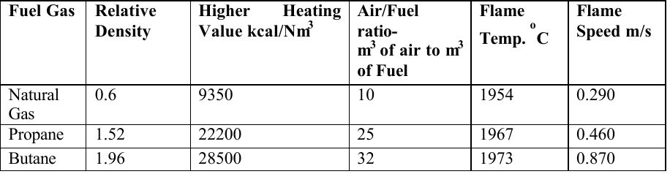
LPG:
LPG is a predominant mixture of propane and Butane with a small percentage of unsaturates(Propylene and Butylene) and some lighter C₂ as well as heavier C₅ fractions. Included in theLPG range are propane (C₃ H₈ ), Propylene(C₃ H₆ ), normal and iso-butane (C₄ H₁₀ )andButylene(C₄ H₈ ). LPG may be defined as those hydrocarbons, which are gaseous at normalatmospheric pressure, but may be condensed to the liquid state at normal temperature, by theapplication of moderate pressures. Although they are normally used as gases, they are storedand transported as liquids under pressure for convenience and ease of handling. Liquid LPGevaporates to produce about 250 times volume of gas.
LPG vapour is denser than air: butane is about twice as heavy as air and propane about oneand a half times as heavy as air. Consequently, the vapour may flow along the ground andinto drains sinking to the lowest level of the surroundings and be ignited at a considerabledistance from the source of leakage. In still air vapour will disperse slowly. Escape of evensmall quantities of the liquefied gas can give rise to large volumes of vapour / air mixture andthus cause considerable hazard. To aid in the detection of atmospheric leaks, all LPG’s arerequired to be odorized. There should be adequate ground level ventilation where LPG isstored. For this very reason LPG cylinders should not be stored in cellars or basements,which have no ventilation at ground level.
Natural gas:
Methane is the main constituent of natural gas and accounting for about 95% of the totalvolume. Other components are: Ethane, Propane, Butane, Pentane, Nitrogen, CarbonDioxide, and traces of other gases. Very small amounts of sulphur compounds are alsopresent. Since methane is the largest component of natural gas, generally properties ofmethane are used when comparing the properties of natural gas to other fuels.Natural gas is a high calorific value fuel requiring no storage facilities. It mixes with airreadily and does not produce smoke or soot. It contains no sulphur. It is lighter than air anddisperses into air easily in case of leak. A typical comparison of carbon contents in oil, coaland gas is given in the table below.

Module-II

Solid fuel:
Solid fuel refers to various forms of solid material that can be burntto release energy, providing heat and light through the process ofcombustion.
Solid fuels can be contrasted with liquid fuels and gaseous fuels. Common examples of solid fuels include wood, charcoal, peat, coal, Hexamine fuel tablets, wood pellets, corn, wheat and other grains.
Solid fuels are mainly classified into two categories,
- Natural fuel : naturally occurred
Example -wood, coal, etc. and
- Manufactured fuels: manufactured by humanbeing/human made/
Example: charcoal, coke, briquettes, etc.
Different types of solid fuels are
- Wood
- Biomass
- Peat
- Coal
- Coke
- Municipal waste
- Fossil fuels
Properties of Solid Fuel:
Specific Heat:
Specific heat is the amount of kCals needed to raise the temperature of 1 kg of oil by 1 degree C.
The unit of specific heat is kcal/kg degree C. It varies from 0.22 to 0.28 depending on the oil specificgravity. The specific heat determines how much steam or electrical energy it takes to heat oilto a desired temperature. Light oils have a low specific heat, whereas heavier oils have ahigher specific heat.
Calorific Value:
The calorific value is the measurement of heat or energy produced and is measured either asgross calorific value or net calorific value. The difference is determined by the latent heat ofcondensation of the water vapour produced during the combustion process. Gross calorificvalue (GCV) assumes all vapour produced during the combustion process is fully condensed.
Net calorific value (NCV) assumes the water leaves with the combustion products withoutfully being condensed. Fuels should be compared based on the net calorific value.
Ash Content:
The ash value is related to the inorganic material or salts in the fuel oil. The ash levels indistillate fuels are negligible. Residual fuels have higher ash levels. These salts may becompounds of sodium, vanadium, calcium, magnesium, silicon, iron, aluminum, nickel, etc.
Carbon Residue:
Carbon residue indicates the tendency of oil to deposit a carbonaceous solid residue on a hotsurface, such as a burner or injection nozzle, when its vaporizable constituents evaporate.Residual oil contains carbon residue of 1 percent or more.

Coal:
Coal is a naturally occurring carbonaceous rock. The coal is formed fromvegetal matter over a long period on the geological time scale. There are manyvarieties of coal occurring in nature. The coal suitable for making of coke isdesignated as coking coal. Every coking coal does not yield coke suitable formetallurgical applications and thus, coals yielding coke for metallurgicalapplications are termed as metallurgical coal.
Origin and formation of coal:
Coal occurs in nature as sedimentary rock where the carbonaceous matter ispresent with many other minerals. The structural examination of the coal showsconfirmed evidence of its formation from vegetal matter. The fossil imprint ofleaf, bark and other tree components on the coal provide evidence of its vegetalorigin. The micro-structural examination of the thin section of coal reveals thepresence of spores, pollens, resins and other essential components of vegetalmatter which help in confirming and identifying the type of tree from whichsuch coal is originated in the nature. It is believed that the large forest vegetationgrowing long ago got buried in the ground and was fossilised to become coal.
There are two theories for origin of coal: ‘In-situ’ theory and ‘Drift’ theory.
- The‘in-situ’ theory describes it as natural growth of trees in swamps, their death andaccumulation as peat over long period of time followed by its coalification tocoal due to some geological action in nature, sustained for long duration of time.

- The ‘drift’ theory differs in first part of the process of coal formation to depositpeat at other location than its growth, while the second stage process is identicalto the ‘in-situ’ theory. The ‘drift’ theory describes the growth of trees in highregions, and these are transported by river water after they die and get uprooteddown to estuary where they get deposited as peat due to lower velocity of water.This deposited peat gets converted to coal by long geological action of the earth.Such peat formation can be noticed even now in Sunderban area of West Bengalwhich is the delta region of Ganges river.
Thus, the process of coal formationcould be divided in two periods:
- Peat formation and
- Conversion of peat into coal.
Peat Formation (Biochemical Period)
- The forests grow in tropical climate. The swamps provide ideal place for thethick growth of the vegetation.
- The trees germinate from the fallen seeds on thesoil. The tender tree grows fast in tropical climate and dies on maturity. Whenthe tree dies, it falls on the ground and starts decomposing or decaying.
- Thisdecomposition (or rotting) process is the disintegration of plant molecularstructure aided by bacteria, moisture and air. When the process of decay of thedead tree is in progress and if another dead tree falls over it then the partiallydecayed tree gets buried in the soft swamp soil and the decay process is sloweddown or arrested depending on the supply of oxygen necessary for the bacterialgrowth. This partially decayed vegetal matter is termed as peat.
- During the process of peat formation, the various constituents decay atdifferent rate. The protoplasm and oils in the plant matter decay rapidly. Thecarbohydrates like cellulose, lignin, etc. decay slowly, whereas the spores,pollens, resins and waxes resist decay action.
- Thus, the nature of vegetation, itsconstituent and extent of decay will decide the peat composition and properties.This process of tree germination, growth, maturity death and partial decayprocess continues to form peat and its accumulation as layers buried under softswamp soil.
- The peat layer thickness depends on the period of peatformation which may be hundreds of years. This peat layer awaits somegeological action to cause its conversion into coal.

Conversion of Peat into Coal (Dynamo-chemicalPeriod)
- The earth crust is dynamic in nature, and it undergoes depression or elevation atany given point due to movement of plates in the earth crust. It may be possiblethat at sometime the area having peat deposit underwent depression causing peatlayer buried at considerable depth with a formation of large depression ofsurface on its top.
- This depressed land filled with rain water would destroy allgrowing vegetation and would look like a huge water lake.
- In every rainyseason, the flowing water to the lake would bring soil and get deposited at thebottom of lake. This soil silting process may continue for long time to eventuallyfill the lake and make it a plain ground over which the vegetation may startgrowing again with peat formation and accumulation to give another layer ofpeat deposit.
- It may also happen that another earth movement may push theburied layer of peat upward creating a mountain like elevated topology. In thisprocess of geological action, the peat layer buried in the soil may be subjected toconsiderable pressure and temperature, rendering chemical and physical changesin peat properties.
- The chemical changes due to application of temperature and pressure wouldbe the loss of moisture and evolution of carbon dioxide and methane.
- Theoxygen content of the carbonaceous matter would be decreased with increase intemperature and time. These conversion changes get reflected in physical nature of thedeposit.
- The colour, hardness and density keep changing with the advancementof the conversion from peat to anthracite.
- The peat has more than 90 percent ofwater and can be squeezed by hand. This water content is reduced in lignitewhich can be felt as wet.
- The bituminous and anthracite coal have very littlemoisture to be felt by hand. The brown colour of the peat becomes dark brown inlignite which further turns black when it becomes bituminous and anthracite.
- The coal hardness also increases with conversion from lignite to anthracite stage.The lignite is friable in nature, while bituminous is hard, but soils the hand withblack carbon. Anthracite is quite hard and does not soil hand on rubbing on itssurface.
TYPE, RANK, CLASS AND GRADE OF COAL
The words like type, rank, class and grade of coal are commonly used todifferentiate its nature which has specific meaning.
Type of coal
The word type of coal indicates whether it is anthracite, bituminous or lignitecoal.
All these three types of coal have distinct properties which render theiridentification.
- Lignite:
It is brown/black in colour with considerable amount ofmoisture to soil the hand. It is fibrous in nature and crumbles easily onpressing. It has high porosity. It contains high volatile constituents withlow fixed carbon.
- Bituminous coal:
It has characteristic layers of bright and dull bandedmatter. It has typical cubic fracture. It is relatively hard (3–4 Mohs scale) innature. It burns easily with smoky yellow flame. It has many commercialapplications. The coking coals falling under this type are used for cokemaking.
- Anthracite:
It is a hard and compact variety of coal with pitch likeappearance. It breaks with irregular fracture and does not soil the finger onrubbing. Anthracite ignites with difficulty, but once ignited, it burns andgives intense local heat with very short and non-luminous flames.Anthracite does not have caking property and is unsuitable for cokemaking. It has limited industrial use as fuel, but often used to makeartefacts.
Rank of coal
The word rank denotes the degree of coalification the peat has undergone toyield coal. The carbon content and calorific value of coal increase with rank,while the volatile matter is found to decrease. The different coals with increasingrank can be shown as:
lignite → bituminous → anthracite.
Class of coal
The term class is retained for its actual use such as coking coal, steam raisingcoal, gas making coal, etc.

Grade of coal
The grade refers to the degree of purity of the coal. The coals with higher ashand moisture content are referred as lower grade coals, while high grade coal,means coal with low ash and moisture content.

COAL CONSTITUENTS
The coal contains various constituents to render specific properties which causeits selection for various applications. These constituents could be grouped inthree categories viz.
- Petrological constituents,
- Elemental constituents and
- Constituents important for its use.
These are discussed in the followingsections.
Petrological Constituents in Coal
The coal contains various constituents which can be identified under geologicalmicroscope. These petrological constituents are known as macerals. Thesemacerals differ significantly in their properties present in various coals. Thesemacerals are grouped as vitrinite, exinite and inertinite.
- Vitrinite:
It is a primary constituent of coal. It usually occurs in bands. It isbright, black and brittle having conchoidal fracture. It is derived fromwoody tissues of the plant from which it was formed. Chemically, it is richin polymers, cellulose (C₆ H₁₀ O₅ )n and lignin (C₃₀ H₃₃ O₁₁ ). It burnseasily during combustion.
- Exinite:
These group of macerals are minor component of coal. These are richin volatiles and hydrogen content that render it most reactive.
- Inertinite
It is oxidised organic material or fossilised charcoal. It is foundas tiny flakes, generally forming 1–3 per cent in coal seam. It is leastreactive group of macerals. The most common inertinite maceral is fusinite.
The natural minerals of different types are also found to be present in coal. Theseminerals get incorporated in early stage of peat formation. The intrinsic mineralmatter originates from minerals present in the wood, since trees need variousminerals as nutrient. These mineral constituents are finely sized and remaindistributed in the whole coal body as fine particles. Such fine size mineral mattercannot be separated from coal by washing methods. The extrinsic mineralmatters are those which get incorporated with peat during its formation andcollection process. The extrinsic mineral matters are present in bulk and could beseparated by coal cleaning methods. These mineral matters are un-combustibleconstituents and remain as ash after coal combustion. These mineral matters arenot desired in coal.

Elemental Constituents in Coal
The major elements present in coal are carbon, hydrogen and oxygen. The minorelements include nitrogen, sulphur and phosphorus. In addition, any knownelement could be present in trace quantity. This elemental analysis is done usingdifferent instrumental techniques. The results of the analysis is reported asweight per cent of each element present in coal including major (in bulk percent), minor (in per cent) and trace constituents (in ppm, i.e., parts per millionand ppb i.e. parts per billion) depending upon its need. Such elemental analysisof coal is reported as ultimate analysis.
The ultimate analysis of coal is useful inestimating air requirements for its combustion, flue gas analysis along withestimation of its calorific value. The presence of minor constituent like sulphur(wt.%) helps in deciding pollution abatement methods caused by its emission.The trace elements in coal would be discharged along with ash and flue gases.The presence and quantity of trace elements in coal help in providing adequatemanagement systems to avoid hazards caused by toxic elements like Hg, As, Cd,Pb, Cr and radioactive elements.

Constituents Important for Coal Use
The coal contains moisture, incombustible inorganic matter and volatileconstituents in addition to carbon. These constituents affect the use of coal. Theproximate analysis of coal deals with the determination of following constituentsby weight per cent:
- Moisture
- Volatile matter
- Ash, and
- Fixed carbon
The knowledge of these constituents is useful in the selection of coal for a givenpurpose.
Moisture
The moisture is present in every type of coal in varying amount (0.5wt.% to 20 wt.%). In peat, the moisture content could be 90 per cent. It is anundesired constituent in solid fuels. The moisture present in the solid fuel isremoved during use at the expense of its heating value. The moisture could bepresent in free (surface), adsorbed (inherent) or combined (chemical compound)state.
- Free or surface moisture
As the name suggests, this kind of moisture is loosely present on the surface orin the pores of coal. This moisture is derived from rain during storage,transportation and washing of coal. When water saturated coal is left in air forsometime, the excess free water evaporates and the moisture content in the coalattains equilibrium with the atmospheric humidity. The per cent weight loss offree water by air drying at room temperature is termed as free or surfacemoisture.
- Inherent moisture
The water molecules adsorbed on the external surface and internal open poresurface is termed as inherent moisture. Its value would depend on porosity andatmospheric humidity. As the lower rank coals possess high porosity, therefore,the inherent moisture content would also be more in lower rank coals comparedto higher rank coals.
The coal sample when heated to 110 ± 5 °C temperature for sometime, thenthe adsorbed (inherent) moisture molecules are detached and get removed.However, if the coal sample is left again in open atmosphere for longer time,then it may regain its inherent moisture content. This regaining tendency forinherent moisture will be more for high rank coals, while this readsorption willbe less in lower rank coals, since their cell walls may breakdown during dryingstage due to weak structure. This reduces the number of pores available forreadsorption of moisture, causing lower inherent moisture in coal sample whichhas been heated and cooled.
This inherent moisture content in coal cannot be avoided. However, a lowervalue would be appreciated.
- Combined moisture
Coal contains mineral matter which, sometimes, contains water molecules thatare chemically attached. Such chemically bonded water molecules do not evolvewhen the coal is heated at 100°C. This kind of moisture can be removed onlywhen the coal is heated at higher temperature. Such combined moisture formsthe part of volatile matter, and it is not determined separately. However, thepresence of combined water in coal is not appreciated as it consumes some heatfor its own dissociation, rendering lower net calorific value of coal for use.
Volatile matter
It is the part of coal which is evolved as volatile (gaseous) product when the coalis heated in the absence of air. As the quantity of volatile product is dependenton temperature, time, surface area, etc., therefore, a specified procedure isadopted to make the result reproducible and comparable.
The quantity of volatile matter in coal may range from 2 wt.% to 40 wt.%,while it is below 2 wt.% in coke and wood char. The volatile matter contentplays an important role during its selection for a given application. Its highercontent could be useful in gas making coals, but may not be appreciated incoking coal. The knowledge of volatile matter content helps in designingcombustion system to provide appropriate primary and secondary air.

Mineral matter and ash
Coal contains various minerals which are uncombustible part of coal, called ash.It is common to state that coal contains ash, but technically coal contains mineralmatter and yields ash on combustion. Chemically, mineral matter is differentfrom ash. The coal may have following minerals in varying quantities in additionto oxides of sodium and potassium:
- Shale or silt (Hydrated silicates ofaluminium)
- Pyrite (FeS₂ )
- Gypsum (CaSO₄.2H₂O )
- Lime stone (CaCO₃ )
- Siderite (FeCO₃)
- Magnesite (MgCO₃ )
- Apatite (Ca₅(PO₄ )₃ (F, Cl, OH )
Some of these minerals originate from the vegetal mass from which the coal wasformed. These minerals are required by the tree for its growth. Such mineralmatter is known as intrinsic mineral matter and is present in very fine form inthe matrix of coal which cannot be liberated or separated by coal cleaningmethods. The bulk of the mineral matter present in coal is incorporated duringpeat formation stage and termed as extrinsic mineral matter. These could bepresent in coarser form which could be removed by coal cleaning methods.
When the coal is heated or burned, the minerals undergo changes dependingupon temperature to yield ash. The ash content in a givencoal is determined by observing the weight of uncombusted matter left afterexposing the coal sample to oxidising condition at 800 °C. In Indian coals,which contain low ‘sulphur’ and ‘carbonate’ minerals, the mineral matter (M %wt.) is given by:
M = 1.1 A
where, A is the ash (wt.%) determined by proximate analysis of coal sampleassuming the sulphur and carbonate are very low.
Fixed carbon
Fixed carbon content in the coal is considered to be useful for a givenapplication, e.g. combustion, reduction, etc. There is no direct method for itsdetermination.
It is estimated as:
Fixed carbon = 100 – [M + VM + A]
where, M, VM and A are moisture, volatile matter and ash content in coaldetermined experimentally.
This fixed carbon value is not the total carbon incoal. A higher fixed carbon content in coal increases its commercial value.
COAL CLASSIFICATION
The coal occurring in nature differs in their properties due to various factorsaffecting its formation. All such coals are classified to help the users in theirselection. The proximate analysis (volatile matter and fixed carbon) and heatingvalue or the ultimate analysis (carbon, hydrogen and oxygen) of coal are used forits classification. There are different systems of coal classification followed invarious parts of the world, developed in the past. These are as follows.
Regnault–Gruner system
The first attempt to classify coal was made in UK in 1837 by Regnault, whichwas modified by Gruner in 1874. This classification system was based oncarbon, hydrogen and oxygen content (%) in coal which were correlated withvolatile matter obtained during carbonisation.
Parr’s system
The American coals were classified by S W Parr in 1928. This classification ofcoal was based on volatile matter percentage and calorific value based on unitcoal basis (coal free from moisture and mineral matter.
Seyler’s system
A comprehensive classification system was developed by C.A. Seyler in 1900.This system was based on calorific value, volatile matter, maximum inherentmoisture and swelling number correlated with carbon and hydrogen contentderived from coal analysis based on dry ash free basis [see section 2.5.2(iv)]. Inthis graphical presentation of coal classification, the different coals were foundto occupy position within fairly defined curved band of data points.
British National Coal Board system
The British National Coal Board attempted to classify Bristish coals in 1950s.Their classification was based on volatile matter content and appearance of solidresidue of coal heated to 600°C (Gray King Assay).ASTM (American Society for Testing Materials) system
The ASTM system was developed for American and Canadian coals by ESherlock in 1949. This system was based on proximate analysis and calorificvalue of coal containing its natural bed moisture excluding any visible surfacemoisture. The ‘weathering’ behaviour of coal was also used as parameter toclassify coal based on its nature to breakdown in pieces when exposed toatmosphere for longer period.

Indian Standards Institution system
The Indian coal and lignites were first tentatively classified by Indian StandardsInstitution (IS-770-1955) in 1955, which was published in 1964 (IS-770-1964)followed by IS-5018-1968. This was further revised in 1977 (IS-770-1977). TheIndian classification is based on gross calorific value and volatile matter contenton dry mineral matter free basis together with GK Assay.
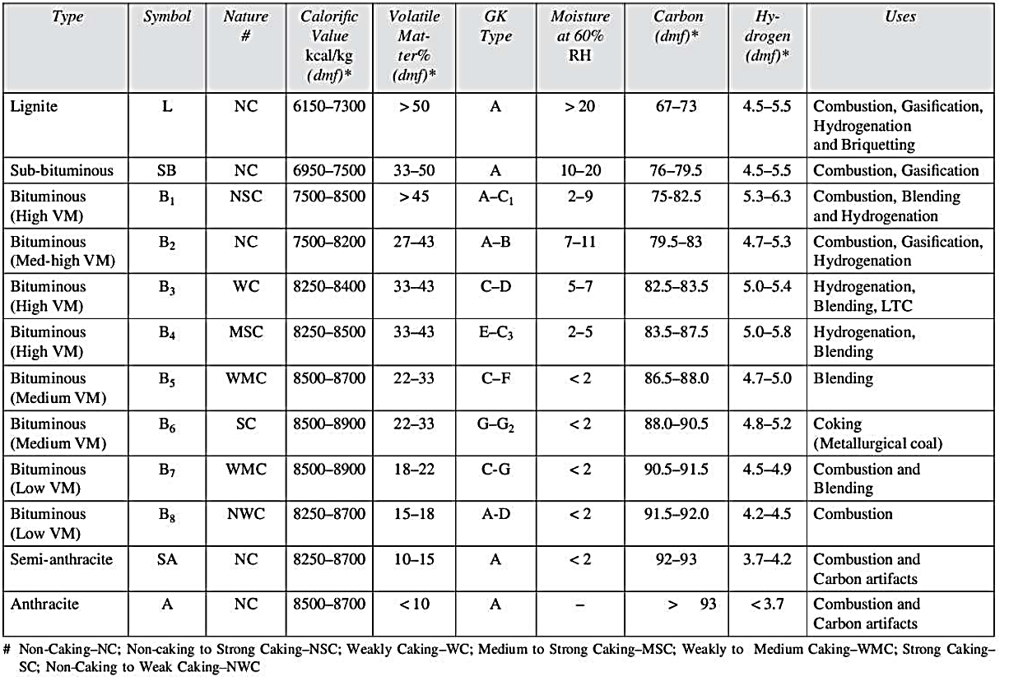

Module-III

Furnace:
A furnace is an equipment used to melt metals for casting or to heat materials to change theirshape (e.g. rolling, forging) or properties (heat treatment).
Since flue gases from the fuel come in direct contact with the materials, the type of fuel chosen isimportant. For example, some materials will not tolerate sulphur in the fuel. Solid fuels generateparticulate matter, which will interfere the materials placed inside the furnace.
For this reason:
- Most furnaces use liquid fuel, gaseous fuel or electricity as energy input.
- Induction and arc furnaces use electricity to melt steel and cast iron.
- Melting furnaces for nonferrous materials use fuel oil.
- Oil-fired furnaces mostly use furnace oil, especially for reheating and heat treatment ofmaterials.
- Light diesel oil (LDO) is used in furnaces where sulphur is undesirable.
Furnace ideally should heat as much of material as possible to a uniform temperature with theleast possible fuel and labour. The key to efficient furnace operation lies in complete combustionof fuel with minimum excess air. Furnaces operate with relatively low efficiencies (as low as 7percent) compared to other combustion equipment such as the boiler (with efficiencies higherthan 90 percent. This is caused by the high operating temperatures in the furnace. For example, afurnace heating materials to 1200 degree C will emit exhaust gases at 1200 degree C or more, which results insignificant heat losses through the chimney.

Basic Features of Furnace:
The basic purpose of a furnace is to have a chamber or enclosure where required working temperature with suitable atmosphere could be maintained with acceptable thermal efficiency, which would be economical in operation and use. In view of this, a furnace will have following features:
- Furnace name: The furnace has a name to identify its features necessary for performing some processes.
- Furnace purpose: The process performed in the furnace has a purpose which could be physical (heating, melting, etc.), chemical (calcination, roasting, smelting, etc.) or physicochemical (e.g. sintering) in nature.
- Furnace temperature: The furnace should have thermal zone which could be low (< 1000 °C), high (> 1400 °C) or very high (~ 2000 °C).
- Energy source: The furnace uses some energy sources like coal, coke, oil, fuel gas or electricity. (e) Furnace shape: The furnace has a typical shape like rectangular chamber, circular tower (shaft), long chamber (tunnel), rotating drum (rotary kiln), etc.
- Furnace material: The furnace has a structure made of a refractory material or combination of refractory materials which would sustain high temperature working conditions.
- Furnace charging and discharging: The furnace structure is designed in such a manner that it facilitates charging and discharging of the processed material.
- Energy conversion method: The furnace has some means to convert the inherent energy in the fuel into thermal energy like grate combustion, pulverised coal burner, oil or gas burner, electrical current flow through resistance or arc gap.
- Heat transfer mode: The furnace uses some means of heat transfer from source to object like thermal conduction, convection or radiation.
- Air supply mode: The furnace gas flow could be due to natural draft or forced draft.
- Batches or continuous operation: The furnace operation could be in batches or made to function continuously.
- Furnace atmosphere: The furnace atmosphere could be made oxidising, reducing or inert in nature.
- Furnace control: The furnace could be controlled manually or made automated.
- Furnace flue gas treatment: The method of discharging flue or waste gases could be after cleaning or without cleaning.

Types of furnaces and classification:
In metallurgical industries, the furnaces are used for applications like drying,calcinations, roasting, agglomeration, reduction/smelting, refining, melting,metal heating for hot deformation, and metal heat-treatment. In these furnaces,various energy sources are used including solid fuel, liquid fuel, gaseous fuels,electrical energy and inherent chemical energy present as carbon, sulphur,phosphorus, silicon and manganese.
In the following sections, some furnaces are described as illustration for usingsuch different energy sources.

- Solid Fuel based Furnaces
The solid fuels like coal, coke, petro-coke and charcoal find application inmetallurgical furnaces as energy source to meet thermal and chemical energyneeds. The furnaces using such solid fuels are illustrated in the followingsections:
Coal based furnaces
- Sponge iron (DRI) rotary kilns
The rotary kilns have emerged as a very popular furnace for making sponge ironusing non-coking coal as reductant and thermal energy source. India is the majoruser of such furnaces in the world due to availability of resources (rich iron oreand non-coking coal).
- COREX iron making technology
This is a new smelting reduction (SR) technology developed in 1980s as analternativemethod of iron making based on the use of coal. This SR method has distinctadvantage of producing liquid hot iron unlike sponge iron (DRI) technology,which delivers solid iron and needs further melting operation. The SRtechnologies have been developed to get liquid iron using easily available non-coking coal, instead of scarce metallurgical grade coke. Such iron making unitsdiffer in design from conventional blast furnace. In India, this technology isadopted only by JSW Steel at Bellary.
- Rotary hearth furnace for sponge iron
This is a sponge iron making furnace based on using coal fines as a reductantmixed with iron ore fines in the form of composite pellets. The main advantageof this furnace is its ability to accept weak dry ore coal mixed pellet on thehearth to cause reduction and strengthening before discharging out in one singlehearth rotation. The compact nature of the furnace to produce DRI using plantwaste is another advantage, responsible for its promotion by many new emergingDRI processes (Commet, ITmk3, Finmet, CPR, etc.). It is limited by its size andsmaller production capacity.
- Steam raising boilers
The boilers use coal to raise steam for various applications in metallurgicalplants such as power generation, humidification of blast in blast furnace,operation of valves, power source, etc.The steam boilers using coal are available in various capacities ranging fromvery smaller one using coal on grate to larger boilers usingpulverised coal combustion for power generation. The coal must be non-caking in nature for thecombustion process.
- Producer gas unit
This is a coal based furnace where coal is burnt partially by limited air supply togenerate gas rich in carbon monoxide alongwith some hydrocarbons evolvedfrom coal volatile matter. The non-cokingbituminous coals are used in the furnace which is lined with fireclay bricks.
Coke based furnaces
- Blast furnace
The blast furnaces are used for the production of pig iron using coke as majorfuel and reductant. This is a tall shaft type reactor which is fed with ferrousburden (iron ore/iron ore sinter/iron ore pellet or their combinations), coke andlime stone from the top, and hot air is blown through tuyers in the lower part ofthe shaft.
- Cupola
The cupola is a melting furnace for cast iron. It is the most common meltingfurnaces used by ferrous foundries. The cupola furnace can be easily obtained orfabricated to melt pig iron and cast iron scrap giving liquid iron (0.5–5 ton/hour)for sand casting. It is common to express cupola size as melting capacity(ton/hour) or its internal diameter (meters) size. A five ton cupola is understoodto have a melting capacity of 5 ton per hour during regular melting operation.The cupola is a widely used cast iron melting unit by ferrous foundries due toits ease of construction and low cost of operation with very low maintenancecost.
- Foundry pit furnace
This is a coke based melting unit in foundries for small scale (5–10 kg) use. Themelting capacity of the furnace depends on the manual handling ability ofcrucible filled with hot melt. Its simpleconstruction and operation make it a popular furnace (temperature 1100–1400°C ) for melting cast iron, copper and copper alloys like brass and bronze usedfor making artefacts in cottage industry. The furnace uses 10–15 mm size coke inpit furnace lined with fireclay bricks.
- Foundry pot furnace
This is a coke based small scale furnace for melting non-ferrous metals andalloys which melt below 600–700 °C. The metals like aluminium, aluminiumbase alloys, tin, lead, cadmium and low melting alloys are melted on small scalein cast iron pot heated by burning coke on grate. The melt is poured out by usingspoon or pot tilting arrangement.
Petro-coke using furnaces
Petro-coke is a by-product of oil refineries as solid residue left after crude oilrefining process. It is virtually free from ash, and has very high carbon content(~ 98%) with very low reactivity. It is used as a reductant for the production offerroalloys like, ferrosilicon, ferromanganese, ferrochrome, ferrovanadium, etc.using submerged arc furnace.
Charcoal using furnaces
Charcoal is a renewable energy source obtained by carbonisation of wood. It isthe best type of solid fuel and reductant having least ash content (< 4 wt. %),high fixed carbon (~ 94 wt. %) and practically very low volatile matter (~ 2 wt.%). Unfortunately, the use of charcoal is not being used due to its non-systematicproduction, currently rendering it as banned item in many countries. Thesystematic agroforestry on waste lands (desert, saline, marshy, rocky, etc.) intropical locations having sun shine more than 300 days/year can yield solid
Carbon(biomass or wood) due to photosynthesis of atmospheric carbon monoxide,moisture and solar radiation (photon) by hard wood plants. This hard woodyields very good charcoal for metallurgical use which has been studied andexperimented in Brazil and India. This has a potential for use in future whenmetallurgical coke will be scare. The biggest limitation with charcoal is its poorcrushing strength which limits the size of shaft furnace (iron blast furnace) usingit as a fuel.
- Liquid Fuel based Furnaces
The liquid fuels like furnace oil, diesel and coal tar fuels (CTF) are verycommonly used in various furnaces for melting and heating applications. Thevarious melting units (e.g. crucible furnace, skelner furnace, mixer, open hearthfurnaces) and heating furnaces (e.g. forging furnace and re-rolling mill furnaces)are described briefly in the following sections:
Melting furnaces
- Crucible furnace
Oil fired crucible furnaces are common melting furnaces used by non-ferrousfoundries in locations where solid fuel is not usable for reasons like lack ofstorage space, problem of ash disposal, high cost of transportation, availabilityand other difficulties for its use. In such oil fired furnaces, the heat transfer fromflame to the melt is poor, since crucible acts as heat barrier resulting in very lowthermal efficiency. In spite of low thermal efficiency, such furnaces, are verycommon in jobbing foundries working on small scale to melt non-ferrous alloyslike brass, bronze, aluminium alloys, etc. These furnaces are popular withindustries located in prime land areas, hilly and cold regions, isolated locationslike island towns, etc.
The furnace appears like a pit furnace with difference that it is oilfired using a burner. The size of the furnace depends on the size of crucible,which can be handled manually or by a portable crane. These furnaces provide1200 to 1300 °C temperature, and fireclay refractory lining serves the purpose.
- Skelner furnace
The non-ferrous reveberatory or the Skelner furnaces are highly durable andused for large scale melting by non-ferrous foundries. These are available inmanual and hydraulic tilting arrangement for pouring melt out from the furnace.These furnaces have a melting chamber lined with fireclay refractory, andequipped with burners and recuperator. The oil consumption is approximately80–100 liter/ton of molten metal in continuous operation.

- Mixer unit for liquid iron storage
The oil fired ‘mixer unit’ in integrated steel plants is used to store liquid ironproduced in blast furnaces. This unit serves various functions like:
- It stores liquid iron produced continuously by blast furnaces when thesteel converters are not operating.
- It homogenises the melt composition from various batches of liquidiron tapped to have a better converter blowing schedule.
- In case of long shut down in steel making unit, it keeps the liquid ironhot using oil burners.
- It also serves to remove sulphur by suitable lime slag during holdingperiod.
The ‘mixer’ is a large cylindrical drum-shaped vessel which can be rotated bycertain degree for pouring out liquid melt. The pouring in of the hot metal byladle is done in vertical position having its spout facing the sky. The fall intemperature is checked by heat energy supply by oil burners. The holdingcapacity of mixers varies from 150 to 1000 ton liquid pig iron. The pig iron isheld at 1450 °C, which requires a good refractory lining. The main requirementsof the refractory lining are:
- Resistance to pig iron erosion and corrosion caused by the slag
- Thermal shock resistance
- Volume stability
- Heat capacity (specific heat of the refractory material) to increase heatstorage.
Such requirements are met by the use of refractories like silica-alumina,alumina or alumina-silicon carbide-carbon composite bricks.
- Open hearth furnace or Siemens-Martin furnace
The oil fired open hearth furnace is an established old furnace design since 1900AD for steel making, and it is still being retained. Currently, this furnace ismainly used by heavy steel casting units in the world due to its ability to supplyquality steel melt in quantities more than 100–500 ton in one batch for makingextra heavy castings like chemical reactor chamber. Such large tonnage of steelmelts in one batch is not feasible by any other steel making furnace. However,these open hearth furnaces have lost their importance for common grades of steeldue to their very slow steel production rate and poor thermal efficiencycompared to pneumatic and electric steel making units.
The open hearth furnace has many merits and few limitations. These arediscussed in the following section.

Merits
  - It can use cold steel scrap or hot liquid melt from mixers holding blastfurnace or cupola melt.
  - It can use oil or gas burners to supply heat during steel making.
  - It can be lined by acid or basic refractory, depending on the slag chemistryinvolved during steel making.
  - It can be designed to prepare molten steel in quantity ranging 50–500tons.
  - The quality of steel made is very high in terms of composition andcleanness with temperature control which is needed for large tonnage steelcastings.
Limitations
- It is a very slow process of steel making.
- It offers very slow heat transfer rate from heat source to metal baththrough insulating slag layer floating on the top of the molten steel.
- It needs high energy input as oil or gaseous fuel.
Heating furnaces:
The oil fired reheating furnaces are common in steel forging and re-rolling units,since they operate independently in locations away from integrated steel works.
The LDO (light diesel oil) is the most easily available furnace oil exploited bysuch units due to its low sulphur content. Such furnaces operate with efficienciesas low as 7 per cent as against up to 90 per cent achievable in other combustionequipment such as boiler. This is because of the high heat losses at highoperating temperature with flue gases. The furnaces of different types areadopted depending on the nature of job to be performed. Some typical furnacesare described in the following sections.
- Forging furnace
The oil fired forging furnaces are used for pre-heating billets and ingots to ‘hotforge’ temperature in the range of 1200–1250 °C. Forging furnaces use an openfireplace system, and most of the heat is transferred by thermal radiation. Thetypical loading in a forging furnace is ~ 5 ton with the furnace operating for 16to 18 hours daily. Specific fuel consumption depends upon the type of materialand number of ‘reheats’ required.
- Batch type re-rolling mill furnace
The oil fired furnaces are used by steel re-rolling mills. These mills use a boxtype furnacefor reheating steel in batches. The furnaces basically use scrap, small ingots andbillets weighing 2 to 20 kg for re-rolling. The charging and discharging of the‘rolling stock’ are done manually, and the final product is in the form of rods,strips, etc. These furnaces are normally operated at ~ 1200–1250 °C with pre-heated stock load capacity of about 10–15 tons per day.
- Continuous pusher type re-rolling mill furnace
This is similar to batch–type furnace with the difference that pusher type furnaceis longer in length and the stock is pushed at one end to dischargeout one billet at another end for rolling. In between the fresh billet pushed in thefurnace and the hot billet pushed out, there are some billets which are being pre-heated and soaked at working temperature(~ 1250 °C). These furnaces can pre-heat ~ 20–25 ton steel stock. The thermalefficiency of these furnaces is better than batch furnace, because the hot fluegases are partially recirculated through rolling stock before exit.
The merits and limitations of these furnaces are as follows:
Merits
- Low capital and maintenance costs
- Heating of top and bottom face of the stock
Limitations
- Frequent damage of refractory hearth and skid marks on rolling stock
- Energy losses from water cooling the skids and stock supporting structure
- Discharging must be synchronised by charging
- Stock sizes and weights with furnace length are limited by friction
- The stock pile-ups is common
- Heating of the rolling stock on all sides is not possible

- Walking hearth and walking beam furnaces
The walking Hearth and Walking Beam furnaces are furnaces where the heatingstock can be moved forward by mechanical movement. The mechanism ofheating is identical in both cases.
In case of walking hearth furnace, a section of refractory lined hearth is usedto raise the rolled stock and move it towards the discharge end in walkingfashion. The mechanism of moving the product is identical in both cases exceptthe type of mechanical arrangement. These furnaces are suited for reheatingalloy steel stock with thinner cross-sections. The design of such furnacesprovides better heat distribution in the furnace. The capacity of such furnacesranges from 30 to 70 ton per hour. The charge size ranges from 0.15 to 0.3 m2cross-section and 6 to 12 m long billets. These furnaces generally use furnace oil(32 liter per ton steel), but can be operated with CNG, coal gas or LPG.

- Gaseous Fuel based Furnaces
The gaseous fuels are known for their merits, and hence are usedin different types of manufacturing processes. Some applications like coke ovenheating, BF stoves, soaking pit furnace, reheating furnaces and heat treatmentfurnaces are described in the forthcoming sections.
- Coke oven heating:
The coke oven utilies its own gas mixed with blast furnace gas to providethermal energyto coking process. The gaseous fuels are combusted in combustion chamberlocated between two coke ovens.The coke oven heating generally uses amixture of coke oven and blast furnace gas for the following reasons:
  - To utilise the fuel gases (coke oven and BF gas) generated in the steelplant
  - The mixing lighter coke oven gas (specific gravity 0.44) with heavyblast furnace gas (specific gravity 1.02) helps in giving better flamepropagation.
  - The mixing rich coke oven gas (5100 kcal/m3 ) and lean blast furnacegas (818 kcal/m3 ) enhances the gas quality.
The producer gas (1450 kcal/m3 ) is sometimes used when the coke oven andblast furnace gas are not available.
- BF stoves
The blast furnace stoves supply hot blast to blast furnaces. These stoves work onregenerator principle.
- Soaking pit furnace
The soaking pits are gas fired large sized deep rectangular furnaces used forreheating steel ingots for hot working. The soaking pit furnace aims to heat largesteel ingots having uniform temperature across its cross-section withoutoverheating the surface within minimum period with least material loss due toscale formation.
These furnaces were the part of old integrated steel plants where ingot castingwas a common practice. The modern integrated steel plants having continuousbillet casting or thin strip casting practice do not require such soaking pitfurnaces. However, these soaking pits find use by non-integrated steel units orindependent hot rolling mills in steel sector. The steel ingots made by scrapmelting in electric furnaces (arc and induction) are used by hot rolling millswhich need soaking pits for ingot pre-heating to hot working temperature.

- Furnaces based on Electricity
The furnaces using electrical energy are very popular in metallurgical industriesfor various operations like drying, heating, melting and smelting. The furnacesare associated with several merits and limitations as discussed below:
Merits
- Clean energy source without any kind of pollution
- Highly energy efficient
- Better temperature control and uniform heating
- Can be used for wide temperature processes up to 2000 °C
- Concentration of high energy in small volume can result in very hightemperature
- Heating can be combined with other operation like electrolysis or electro-corrosion
- Selective zone heating is possible by using induction coil for case hardening
- Furnace can be easily automated
- Less floor area requirement by the heating system
Limitations
- Expensive energy source with less availability in many parts of the region
- Initial high cost of installation including transformer cost, sub-station cost,cable cost, etc.
- Furnace operation is subjected to power quality in terms of continuity ofsupply voltage, frequency, etc.
- Power failure due to variety of reasons can interrupt furnace operation.
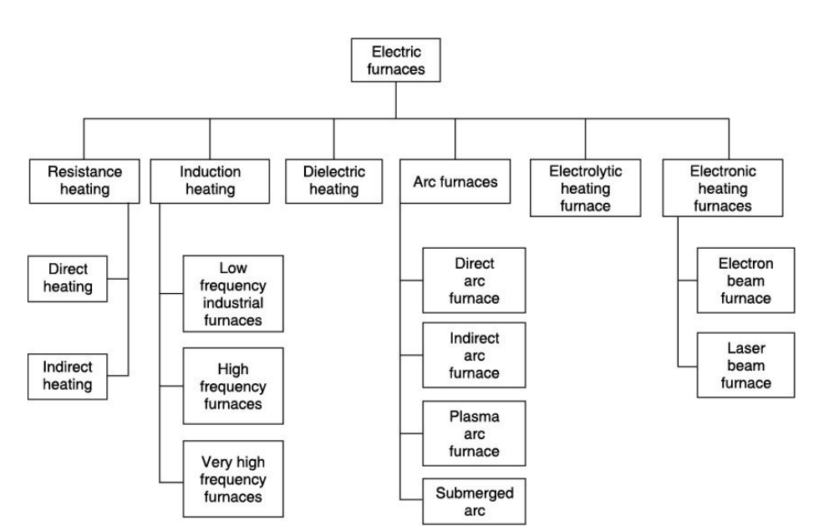
Industrial application of furnaces:
- Use in molding
- Use in ceramic industry
- Glass industry
- Annealing purpose
- Debinding purpose
- Use in sintering process
- Use in calcination process
- Use in brazing
- Use in metallizing
- Thermal cycling

Design and construction aspects of furnaces:
All furnaces have the following components:
- Refractory chamber constructed of insulating materials to retain heat at high operatingtemperatures.
- Hearth to support or carry the steel, which consists of refractory materials supported by asteel structure, part of which is water-cooled.
- Burners that use liquid or gaseous fuels to raise and maintain the temperature in the chamber.
- Coal or electricity can be used in reheating furnaces.
- Chimney to remove combustion exhaust gases from the chamber
- Charging and discharging doors through which the chamber is loaded and unloaded. Loadingand unloading equipment include roller tables, conveyors, charging machines and furnacepushers.

A Blast Furnace:
The blast furnaces are used for the production of pig iron using coke as majorfuel and reductant. This is a tall shaft type reactor which is fed with ferrousburden (iron ore/iron ore sinter/iron ore pellet or their combinations), coke andlime stone from the top, and hot air is blown through tuyers in the lower part ofthe shaft.
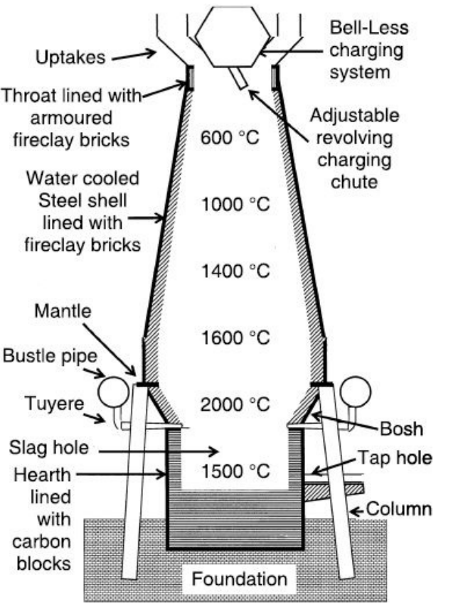

Design:
The various components of the blast furnace and its profile are depictedin above figure. The profile of the blast furnace indicates variation in its diameterfrom top to bottom. Such profile of the blast furnace has been achieved due tooperational requirements. The ‘throat’ at the top is a short cylindrical sectionwhere the charging device is fitted. The upper section, known as ‘stack’, is a tallfrustum of cone whose larger diameter is at lower end and matches with‘belly/bosh’ diameter. The stack smaller diameter matches with ‘throat’ diameter.
The increase in diameter size with downward height is indicated by ‘inwallbatter’ in mm for every 1 m depth. The angle between sloping ‘stack’ wall andhorizontal is known as ‘stack angle’. The section joining ‘stack’ and ‘bosh’ isknown as ‘belly’, which is a short height cylindrical section. The lower section‘bosh’ is again a frustum of cone with down end smaller diameter, matching with‘hearth’ diameter and upper wider end diameter matches with ‘belly’ diameter.The increasing stack diameter serves to provide easy solid material decentunder gravitational force, and also provides extra volume to accommodate theincreased volume of expanding burden due to thermal expansion and chemicalreactions (iron ore swelling behaviour under reduction). The ‘belly’ is cylindricalin shape as the burden material is mostly reduced, hot and fused mass which candecent down under overburden load. The following ‘bosh’ section is invertedcone with decreasing diameter as in this section the solid reduced ferrous burdenand slag gets molten due to high temperature occupying lesser volume.
The blast furnaces are designed to produce hot metal under varied conditionsof raw material quality and many other considerations. These varied factorsresult in blast furnace having working volume ranging from 100 to 5000 m3 andyielding ~ 300 to 10000 ton hot metal per day. The increasing size of the blastfurnace increases demand for quality of raw materials including coke quality andthe refractory quality, which have not only to sustain high temperature but haveto bear high working load alongwith erosive and corrosive conditions prevailinginside the blast furnace due to counter current movement of solid burdenmaterials and escaping hot reducing gases.
Working:
The ferrous burden with coke and limestone descend down in the blastfurnace against upward flow of hot reducing gas. This hot reducing gas, rich incarbon monoxide, is generated at tuyers level by the reaction of hot coke andoxygen in air blown into it. The reducing gas causes reduction of ferrous burden,and the iron oxide is converted into metallic iron which melts to get collected inthe hearth. The unreduced oxides in the burden, ash in coke, lime, etc. combineto form slag, which is also collected in the hearth in molten form floating on thetop of the liquid bath. The liquid hot metal and slag both are tapped outperiodically through respective tap hole and slag notch.

Chimney design:
The chimney is a structure which provides draft for hot flue gasesfrom a boiler, stove, furnace or fireplace to the atmosphere. The chimneys aretall vertical structure to provide exit to flue gas or waste gas from a furnacesystem.
The operating principle of the chimney depends on the type of methodadopted for the draft of gases, i.e., ‘natural draft’ or ‘forced draft’.
- The natural draft chimney works under draft due to buoyancy created by thehot gases in the chimney. The furnace exit gases are hot and have density lowerthan gas at lower temperature. The hot gases with lower density have upwardmovement in the chimney which creates a natural draft and cold gas (air) fromthe atmosphere enters the furnace system due to negative pressure (draft) createdby hot rising gases. The rate of flow of gases would depend on the draft(pressure difference) created and area of cross-section of the chimney. Thetypical example of using such chimney is building red brick kilns which requireslow draft for gradual combustion of coal and slow firing rate of clay bricks.
- The forced draft is common with industrial furnace where large volumes offlue gases have to be removed and discharged at higher heights for diffusing thegases in the atmosphere to minimise pollution effect. This requires blower fansof suitable capacity to force the gases in the chimney under pressure greater thanatmospheric pressure to cause movement in tall chimneys.
The height of a chimney influences its ability to transfer flue gases to theexternal environment due to forced draft effect. The dispersion of pollutants athigher altitudes helps in reducing their impact on the immediate surroundings. Inthe case of chemically aggressive output, a sufficiently tall chimney can allowfor partial or complete self-neutralisation of air-borne chemicals before theyreach ground level. The dispersion of pollutants over a greater area can reducetheir concentrations and facilitate compliance with regulatory limits.The chimney structure is made of steel or steel-cement-concrete depending onthe nature of flue gases and structural considerations, keeping seismic factor inview for safety.

Process efficiency:
A furnace’s efficiency increases when the percentage of heat that is transferred to the stock orload inside the furnace increases. The efficiency of the furnace can be calculated in two ways,similar to that of the boiler: direct method and indirect method. Both methods are explainedbelow.
Direct method
The efficiency of a furnace can be determined by measuring the amount heat absorbed by thestock and dividing this by the total amount of fuel consumed.
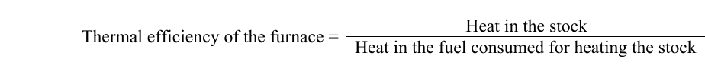
Indirect method
The furnace efficiency can also be determined through the indirect method, similar to theevaluation of boiler efficiency. The principle is simple: the heat losses are substracted fromtheheat supplied to the furnace.
Typicalthermal efficiencies for common industrial furnaces are as follows:
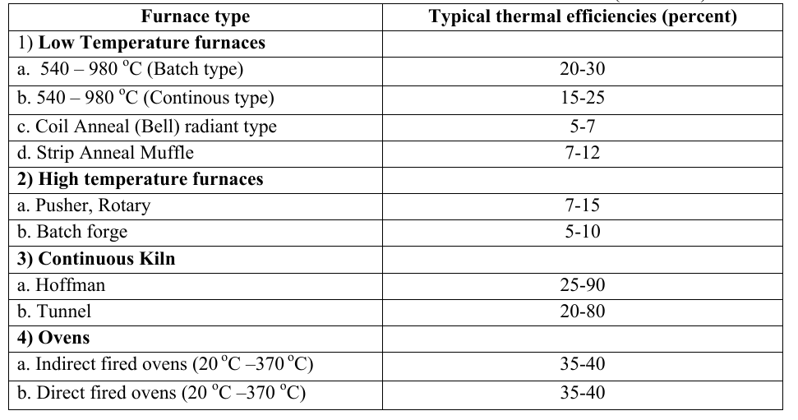

Module-IV

Refractories:
The refractory is an essential requirement for any furnace to sustain hightemperature. These refractory materials must possess sufficiently high fusiontemperature to retain their shape at working temperature. Further, such materialsmust have required porosity, strength at high temperature, thermal conductivity,resistance against corrosion and erosion with many other properties at affordablecost. The production of quality refractory with low cost has always posedchallenge to ceramic industries. The larger high temperature metallurgical units(e.g. blast furnaces producing more than 4000 ton hot metal per day) constructedthese days for economic reasons, demand very stringent quality of refractorymaterials.
The refractory materials are required to possess many properties. Refractorymaterials should have the ability to:
  - withstand high temperature
  - withstand corrosive action of molten slag and hot gasses
  - withstand abrasion and erosion by moving solid charge, flowing liquidsand blowing gases
  - withstand working load during service
  - retain dimensional stability at working temperatures
  - sustain repeated thermal cycling
  - sustain thermal shock (sudden change in temperature)
  - conduct/resist heat flow as needed during use
  - store heat in the system
In addition to the above properties, the availability of refractory at suitablecost would be a desirable factor for its use.

Properties and testing methods of Refractories
- High Temperature Behaviour:
The refractory materials are required to serve at high temperature,and hence they must have sufficient strength at working temperature to retaintheir shape and size. This high temperature strength becomes more importantwhen the size of the furnace is large and load on the hot refractory structurebecomes high. It must be noted that strength measured at room temperature isnot the indication for its fitness to use the refractory at high temperature. As weknow that any solid material when heated starts becoming soft at sometemperature due to fusion/melting at grain boundaries, and eventually it becomesliquid at its melting point. This requires the knowledge of maximum temperaturefor safer use of the refractory. This high temperature behaviour of the refractoryis tested by measuring the following properties:
- PCE (Pyrometric Cone Equivalent) value
- RUL (Refractoriness Under Load) value
- Creep at high temperature
- High Temperature Modulus of Rupture (HMOR)
- Thermal shock resistance
– Spalling test
– Loss in MOR strength
- Reversible thermal expansion
- PLC (Permanent Linear Change) test

- PCE (Pyrometric Cone Equivalent) value
It is the measure of refractory’s ability to sustain high temperature without fusionor deformation. This is measured by heating a standard size cone made of thematerial to be tested in a furnace alongwith another standard cone havingrefractoriness very close to the test material (determined by a pre-test), andnoting the furnace temperature at bending (9′ or 3′ o’clock positions viewedupside down) of the cone inclined at one end due to its own weight.
- RUL (Refractoriness Under Load) value
It is the capability of a brick to sustain itself without breaking at hightemperature under pressure of overlying load. This working load could be due toburden, liquid metal or its own structural weight. In simple words, RUL is thecrushing strength of a brick at elevated temperature. The crushing strength of therefractory brick is lowered at elevated temperature due to fusion/melting of grainboundaries.
- Creep at high temperature
Creep is a property which indicates deformation of the refractory at hightemperature which is subjected to stress for longer period.
- High Temperature Modulus of Rupture (HMOR)
It is the maximum stress that a rectangular test piece of defined size canwithstand when it is bent in a three point bending device. It isexpressed as N/mm2 or MPa.

- Thermal shock resistance
Thermal shock resistance is a measure of refractory property when it is exposedto alternate heating and cooling. This thermal shock leads to breaking ofrefractory particles which is termed as ‘spalling’ and loss of strength due tomicro-cracks and is noted as MOR value after thermal treatment.
- Thermal expansion
The increase in volume of the material due to heating is called thermalexpansion. This expansion process is reversible in nature, and material regainsits size on cooling, hence, it is also called reversible thermal expansion . It is theinherent property of all the materials. This property is measured as linearexpansion with heating due to practical reasons. Figure 7.8 shows the thermalexpansion of some refractory items.
- PLC (Permanent Linear Change) test
The materials expand on heating, but they regain original shape on cooling(reversible thermal expansion). The permanent linear/volume change refers tonon-reversible expansion in the refractory materials due to heating process.
This permanent linear/volume changes could be due to the following reasons:
- Phase changes in the refractory due to allotropic forms having differentspecific gravity.
- Chemical reactions causing formation of new compound having differentspecific gravity. This could be due to chemical attack by gas or slag in thesystem leading the formation of different compounds with changedproperties.
- Sintering of the material causing densification and shrinkage.
- Melting of some phase causing densification and shrinkage.

- Corrosion Resistance
It is the wear and tear of refractories caused by static chemical attack of slag.The eating away of refractory material due to chemical reaction betweenrefractory and molten fluid (slag) at high temperature is termed as ‘refractorycorrosion’.
- Erosion Resistance
The ability of a refractory to sustain the mechanical erosive action of slidingburden, moving products (liquid melt and slag), flowing gases (e.g. hot fluegases laden with solid particles) is termed as ‘erosion resistance’.

- Thermal Conductivity
Thermal conductivity is defined as the quantity of heat that will flow through aunit area in a direction normal to the surface area in a given time with a knowntemperature gradient under steady state thermal conditions. It is indicative ofheat flow characteristics of the refractory and depends upon the nature ofmineralogical constituents as well as the physical properties of the refractories.
- Porosity
Porosity is a measure of the vacant space as pores and voids/cavities in therefractory material. The pores and cavities could be differentiated on their lengthto diameter ratio. The pores have longer length and their length to diameter ratiois more than the cavity.The pores present in refractory are of three types: open pores, inter-connectedpores and sealed pores. These are explained in the following sections:
- Open pores
These have one of their ends on the outer surface of the particle. This open endallows the movement of fluids (gas/liquid) to the interior location of the particlepermitting chemical reaction and adsorption/absorption processes. The liquidmetal may penetrate under pressure and get solidified to cause refractory failure.The refractory with large sized open pores are undesirable for places facingliquid metal or slag.
- Interconnected pores
These have both of their ends opening to the outer surface of the refractory. Thisallows a free movement of fluids (gas/liquid) and offers site for chemicalreactions and adsorption/absorption of fluids. Such pores are useful inmanufacturing ceramic filters, but are not desirable in refractory brick used infurnaces which may cause leakage of gases in the furnace.
- Sealed pores
There are deep seated and do not open up to the surface of the particle. Thesesealed pores do not offer any site for chemical reaction nor allowadsorption/absorption of fluids. However, these sealed pores act as a goodthermal barrier and increase the heat insulating power of the material. Suchsealed pores are useful while making heat insulating materials.
- Density
The refractory is a porous material, and therefore its density is seriously affectedby pore volume. Following three terms are used to differentiate various types ofdensity values:
True density
This refers to the ratio of mass to volume of solid particle without any pores orcavities.
Apparent density
It refers to the ratio of mass to volume of a single solid particle including closedpores (i.e., volume of solid material + volume of closed pores within theparticle).
Bulk density
It refers to the ratio of bulk mass to total bulk volume (solid volume + porevolume + void volume) of the refractory brick.
- Cold Crushing Strength (CCS)
The cold crushing strength (CCS) represents the ability of a refractory to resistfailure under compressive load at room temperature. The compressive load isapplied on the refractory block till its fracture. The CCS is then calculated astotal load applied divided by the surface area.

Types of Refractories:
- Classification of Refractory based on ChemicalNature
The furnaces use several types of refractory bricks made from refractorymaterials. The refractory materials are generally classified on the basis of theirchemical behaviour, i.e., their reaction to the type of slag. Accordingly,refractories can be classified as: acid, basic and neutral.
Acid refractories
Acid refractories are those which are attacked by basic slag. These are notaffected by acid slag, and hence it can be used in furnaces having acidic workenvironment. The following types of refractories fall in this group:
(a) Silica(most acidic)
(b) Semi silica
(c) Alumino-silicate refractories (e.g. high alumina (as exception since itreacts with slag), Fireclay group refractory (e.g. LHD-Low Heat Duty,HHD-High Heat Duty, SD-Super Duty and Grog), Kyanite, Sillimanite andAndalusite.
Basic refractories
Basic refractories are those which are attacked by acid slag. These refractoriesare of considerable importance for furnace linings where the environment isbasic, for example, basic steel making and furnaces for non-ferrous metallurgicaloperations. The following refractories fall in this category:
(a) Magnesite
(b) Magnesite-Chrome
(c) Chrome-Magnesite
(d) Dolomite
(e) Forsterite
Neutral refractories
These refractories are attacked neither by acid nor by basic slag. The followingrefractories are known for their inertness:
(a) Graphite (most inert)
(b) Chromites
(c) Synthetic refractories (e.g. zirconium carbide and silicon carbide)

- Classification of Refractory based on OtherConsiderations
The refractory materials find high temperature applications in many forms andshape. These refractory materials could be classified as: Special refractories,Insulating refractories and Cermets.
Special refractories
These refractory materials are specially manufactured using synthetic(fused/sintered) grains free from impurities under highly controlled productionparameters for special applications. They are used for purposes like fabricationof crucible, some parts of furnaces and research and developments. Theseapplications of the refractory do not consider cost as a factor for selection. Therefractories included in this group are:
(a) Alumina,
(b) Pure sialons (Si-Al-O-N),
(c) Thoria (ThO₂ ),
(d) Beryllia (BeO),
(e) Zirconia,
( f ) Boron nitride,
(g) Spinel, etc.

Insulating refractories
These are high porosity refractories having low thermal conductivity used forreducing the rate of heat flow (heat losses) to maximize heat conservation withinthe furnace. The development and application of a wide variety of insulatingrefractory materials are gaining importance with increasing energy costs inpresent days. The production of brick shape refractories utilises China clay,asbestos (kieselguhr), glass wool, mica (vermiculite), bubble alumina, carbon,paper wool, ceramic fibers, saw dust, etc. as raw materials.
Cermets
The refractories produced from the mixtures of high purity refractory oxides,carbides, borides, and metals or alloys fall under this category. Depending on thecomposition and quality, they are used as abrasives (cutting, grinding, boringtools), in parts of spacecrafts, missiles, atomic power plants, etc.

RAW MATERIALS FOR REFRACTORY MANUFACTURE
The refractory preparation exploits natural resources together with syntheticmaterials. These refractory raw materials can be broadly divided into twocategories: clay based and non-clay based.
Clay based Refractory Raw Materials
The naturally occurring clays having high percentage of refractory constituentsfind use in refractory industry. These include fireclay and high alumina clays.
Fireclay
It is generally defined as a “mineral aggregate composed of hydrous silicates ofaluminium (Al₂ O₃ .2SiO₂ .2H₂ O) with or without free silica”. It is also knownas kaolinite. It is generally found as white in colour, but sometimes red, blue orbrown tints come from impurities.
High alumina clay
It is composed of bauxite riched or other raw materials that contain 50 to 87.5%alumina. High alumina refractories are generally multipurpose, offeringresistance to chipping and higher volume stability. High alumina refractories areused to produce brick and insulating refractories.
Non-clay based Refractory Raw Materials
These refractory materials are prepared from naturally occurring minerals andsynthetically processed materials.

Magnesite
It is a mineral with the chemical formula MgCO₃ (magnesium carbonate). It isfound as colourless, white, pale yellow, pale brown, faintly pink, lilac-rosemineral having conchoidal fracture, possessing hardenss of 3.5–4.5 on mohsscale.
Extra-high alumina
It is prepared predominately from bauxite or alumina (Al₂ O₃ ). The extra-highalumina refractories contain 87.5% to 100% alumina and offer good volumestability. They are typically poured into special shapes using a fused castingprocess.
Mullite
Mullite ( Al₆ Si₂ O₁₃ ) is made from kyanite, sillimanite, and alusite, bauxite ormixtures of alumina silicate materials. The mullite refractories contain ~ 70%alumina. It possesses specific gravity of 3.11–3.26 and hardness 6–7 on Mohsscale. They maintain a low level of impurities and high resistance to loading inhigh temperatures.

Silica
The quartz mainly containing silica is used for this purpose. The silicarefractoriesare characterised by a high coefficient of thermal expansion between roomtemperatureand 500 °C. Silica bricks are prepared in three grades: super-duty (low aluminaand alkali), regular, and coke oven quality. Silica compositions can be used forhot patching, shrouds, and bricks.
REFRACTORY MANUFACTURING PROCESS:
Refractory manufacturing process basically consists of four steps:
(i) Raw material processing
This step involves crushing and grinding of raw materials obtained from varioussources followed by their classification according to particle size by screeningand sieving. These raw materials also sometimes need washing, calcinations anddrying operations to meet the chemical specifications. The dry refractory powderof one size is mixed with other size to meet specific grain size distributionalongwith other chemical constituents desired for specific need. The dryrefractory powder is packed and marketed as such for various applications. Thisdry refractory powder mass with specific size mix serves as feed for makingrefractory bricks and other components.

(ii) Shaping
The dry powder is mixed with water and other additives to prepare wet dove forgiving shape to the refractory using different types of machines and technique.The shaped refractory is air dried before firing.
(iii) Firing
The shaped refractory is subjected to firing to cause heat hardening by ceramicbonds and bring desired phase changes to have a stabilised refractory. This firingis done in kilns having high temperature caused by combustion of fuels mostlygaseous in nature for better quality product.
(iv) Final processing
The final processing step includes milling, grinding, and sand blasting of thefinal product to give finished and desired surface quality. The certain productsmay also need impregnation with tar/pitch or armouring by some other materiallike steel sheet. Finally the products are packaged for safe transportation.
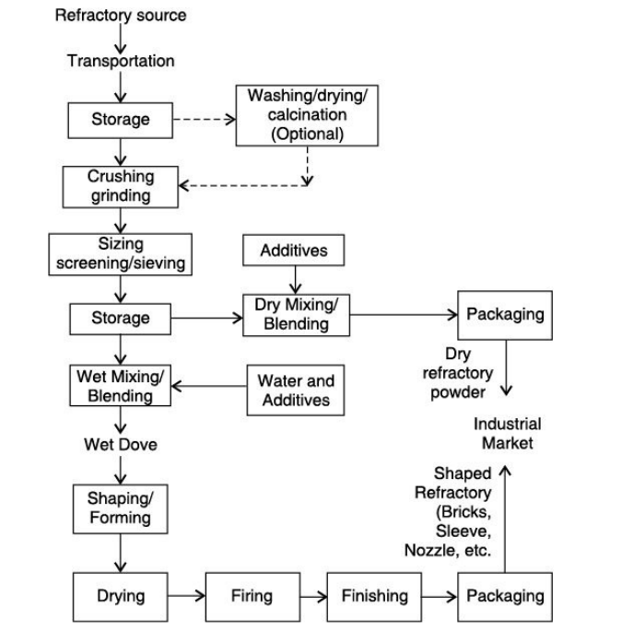
Monolith:
Monolithic refractories are single piece casts in the shape of equipment, such as a ladle. They are rapidly replacing the conventional type fired refractories in many applications including industrial furnaces. The main advantages of monolithics are:
- Elimination of joints which is an inherent weakness
- Faster application method
- Special skill for installation not required
- Ease of transportation and handling
- Better scope to reduce downtime for repairs
- Considerable scope to reduce inventory and eliminate special shapes
- Heat savings ƒ Better spalling resistance
- Greater volume stability
Monolithics are put into place using various methods, such as ramming, casting, gunniting, spraying, and sand slinging. Ramming requires proper tools and is mostly used in cold applications where proper consolidation of the material is important. Ramming is also used for air setting and heat setting materials. Because calcium aluminate cement is the binder, it will have to be stored properly to prevent moisture absorption. Its strength starts deteriorating after 6 to 12 months.
Energy conservation in furnaces:
Ideally, all heat added to the furnaces should be used to heat the load or stock. In practice, however, a lot of heat is lost in several ways.
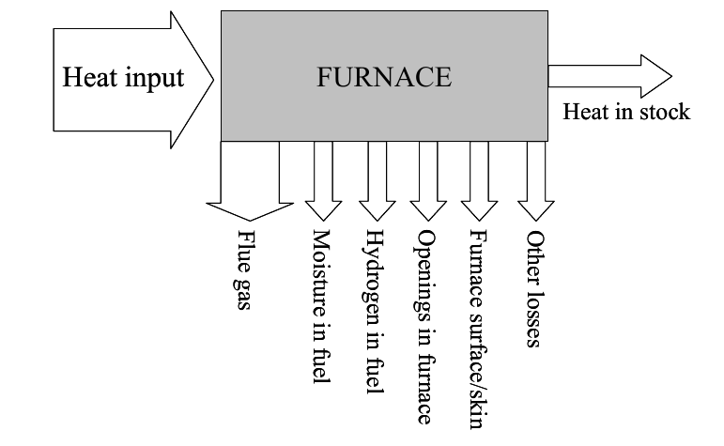
Thesefurnace heat losses include:
- Flue gas losses: part of the heat remains in the combustion gases inside the furnace. Thisloss is also called waste-gas loss or stack loss.
- Loss from moisture in fuel: fuel usually contains some moisture and some of the heat is usedto evaporate the moisture inside the furnace
- Loss due to hydrogen in fuel which results in the formation of water
- Loss through openings in the furnace: radiation loss occurs when there are openings in thefurnace enclosure and these losses can be significant, especially for furnaces operating attemperatures above 540°C. A second loss is through air infiltration because the draft offurnace stacks/chimneys cause a negative pressure inside the furnace, drawing in air throughleaks or cracks or when ever the furnace doors are opened.
- Furnace skin / surface losses, also called wall losses: while temperatures inside the furnaceare high, heat is conducted through the roof, floor and walls and emitted to the ambient aironce it reaches the furnace skin or surface.
- Other losses: there are several other ways in which heat is lost from a furnace, althoughquantifying these is often difficult. Some of these include
− Stored heat losses: when the furnace is started the furnace structure and insulation is alsoheated, and this heat only leaves the structure again when the furnace shuts down.Therefore this type of heat loss increases with the number of times the furnace is turnedon and off
− Material handling losses: the equipment used to move the stock through the furnace, suchas conveyor belts, walking beams, bogies etc, also absorb heat. Every time equipmentleave the furnace they loose their heat, therefore heat loss increases with the amount ofequipment and the frequency by which they enter and leave the furnace
−Cooling media losses: water and air are used to cool down equipment, rolls, bearing androlls, but heat is lost because these media absorb heat
-Incomplete combustion losses: heat is lost if combustion is incomplete because unburntfuel or particles have absorbed heat but this heat has not been put to use
-Loss due to formation of scales

ROLE OF REFRACTORY:
- A good refractory reduces the heat loss from the furnace
- Reduce the energy requirement
- A good refractory can sustain repeated thermal cycling and hence help less fuel consumption.
- By sustaining sudden change in temperature reduces need of controlling the temperature more times
- Can store heat in the system
Uses of Refractory:
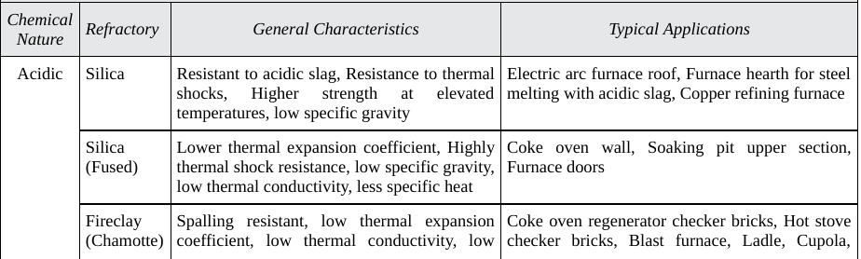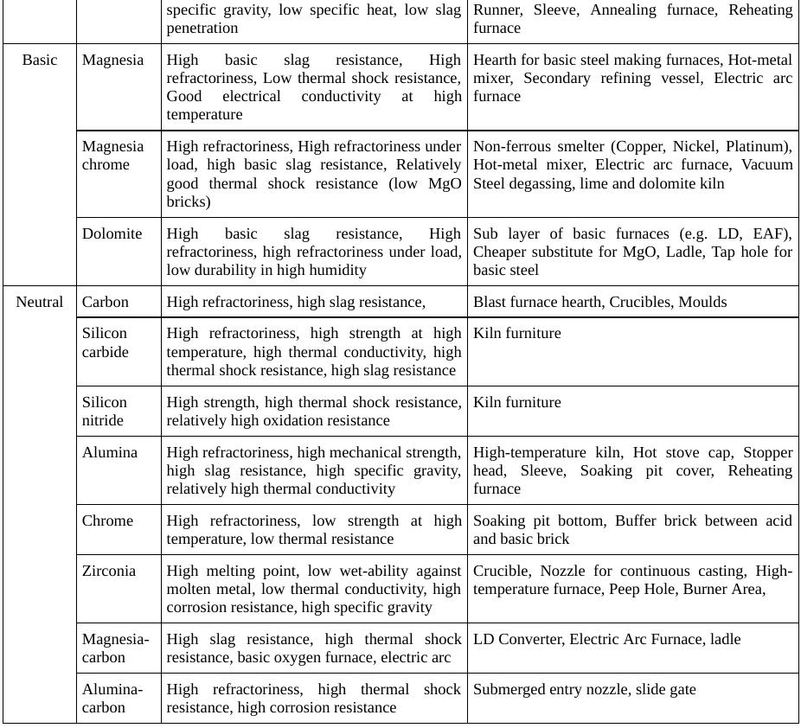

References:
1. Elements of Fuels, Furnaces and Refractories by O.P. Gupta, Khanna Publ., 1997
2. Fuels and refractories by Book by J. D. Gilchrist
3. https://www.economicsdiscussion.net

